**Hospital Management System for Mayo Clinic**

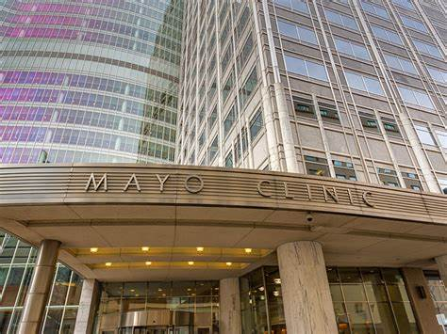

Simplilearn Project for CBAP

Submitted by: Yellepeddi Veera Nachiketa

Table Of Content: -

Introduction (Overview)

1. Task 1: Identify Stakeholders
2. Task 2: Describe proposed workflow
3. Task 3: In scope and Out-scope items for HMS
4. Task 4: Scope of Hospital Management System (Context Diagram) UML
5. Task 5: Main Features of HMS
6. Task 6: ER Entity Relationship diagram
7. Task 7: Data flow diagram for HMS
8. Task 8: Functional and non-functional diagram of HMS.
9. Task 9: flowchart for patient admission process
10. Task 10: Mock screens using **FIGMA** screens home page and registration screens.

**Overview**:

1. Mayo Clinic holds the number 1 rank among hospitals in the United States, which was opened on 30th of September 1889.
2. It was based in three major locations Rochester, Minnesota; Jacksonville, Florida; and Scottsdale, Arizona.
3. Mayo Clinic Focuses on patient care, education, and research.
4. As vast number of patients it treated, made management a huge hospital and tremendous task to maintain all the data of patient.
5. Hence, Hospital management decided to invest in building a software called Hospital Management System (HMS).

**Advantages of HMS**:

1. Reduce operating Cost of hospital.
2. Easy access to patient data
3. Reduce documentation in hospital
4. Saves patient time
5. Storing the medical report of patients for further references.
6. To track available beds.

**Requirements of Client**.

1. It should help patient to see the availability slot of doctors and able to display available timings of doctors.
2. Should send the reminders of appointment via email or SMS one day priorly to patient.
3. We need to generate a patient ID when a new patient comes in and that id will be used throughout their stay in hospital and gets deleted once patient checks out.
4. It shows bed occupancy for every 6 hours no of beds available and occupied.
5. Billing will be provided at the check out time for overall expenses which will reduce multiple billings for single person.
6. If doctor suggests to have blood test, same will be entered by doctor in HMS and same will be received by Laboratory, blood bank, radiation department directly. Once the test was done they will repost the reports into the HMS and doctor will login and check the reports and it will also store in cloud for further use.
7. Every single reports will be generated in HMS to senior management for clear view of billing, revenue, beds occupied etc.
8. Attendance for staff how many hours they were working and in which ward they were working.
9. All the instructions given by the doctors for nurse to follow up what treatment to be done and when it to be done.
10. In case if patient have insurance, all the insurance details will be stored for further claiming process.
11. Management also needs

### Bed occupancy for each day

* 1. Doctors’ appointment and revenue generated through OPDs
  2. Total number of OPD patients and admitted patients
  3. Which doctors generate the maximum revenue
  4. Total amount generates the maximum revenue
  5. Total amount of earnings through OPD and admitted patients
  6. Total amount of earnings generated through laboratory and radiology

**System requirements**: -

1. Database: - My SQL database need to be used since it is open source and free
2. OS: - Shall be windows 2016
3. Should use web-based application.
4. Response time should be 1 second
5. System must support 500 people using at a time.
6. System shall keep a log of errors
7. System should be available 24/7
8. Screens should be very user friendly and able to understand by everyone.

**To determine overview in BA core concept model**

**NEED-**  to create HMS as increase in Hospital size and number of visits of patients.

**CHANGE-** change is required in-order to reduce operating cost and make appointment easy for patient and to store the medical reports in cloud.

**SOLUTION:-** To create HMS to make appointment easy, availability of beds, easy billing, easy access for medical reports, reminder of appointment, and to store all data in cloud.

**STAKEHOLDERS:-** Domain SME, BA, Project manager, hospital management, developer, tester, regulator, sponsor, supplier

**VALUE: -** Reduce operating cost, reduce time efforts of patient, reduce paper work and to keep records of patient in cloud.

**CONTEXT: -**  Doing manual work increase occupancy of place for storing files and includes lot of efforts. To reduce those efforts HMS need to be in existence.

TASK-1

Identifying the stakeholders.

On referring BABOK I have chosen RACI model to identify the various responsibilities of different stakeholders.

An overview of RACI model

R- Responsible (One who is responsible for any changes or work)

A-accountable (One who needs to answer)

C- Consulted (one who is reached for opinions)

I-Informed (One who kept informed about any major/ minor changes)

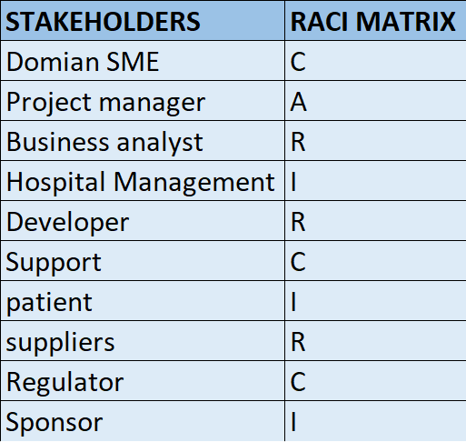

Stakeholders: -

* + 1. INTERNAL STAKEHOLDERS: -

Project Manager

Developer

Domain SME

Support

* + 1. EXTERNAL STAKEHOLDERS: -

Hospital management

Patient

Suppliers

Regulators

Sponsor

* + 1. BUSINESS ANALYST

**TASK-2**

PROPOSED WORKFLOW: -

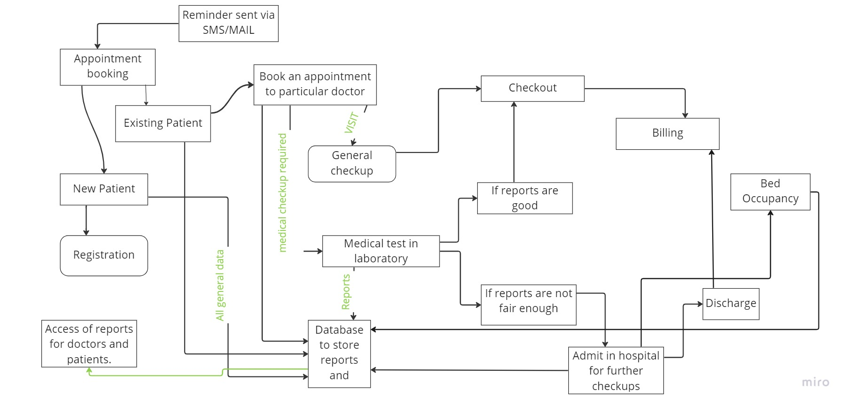

TASK-3

IN-SCOPE AND OUT SCOPE OF THE HMS: -

In-Scope

Appointment Scheduling.

Appointment reminders.

Registration.

Medical reports.

Lab test reports.

Bed occupancy.

Billing and medical reports generation for senior staff to give best advice.

**Out-Scope**

Details of hospital staff.

Annual income of hospital.

Number of staff working in Hospital.

**TASK-4**

**Context or UML diagram.**

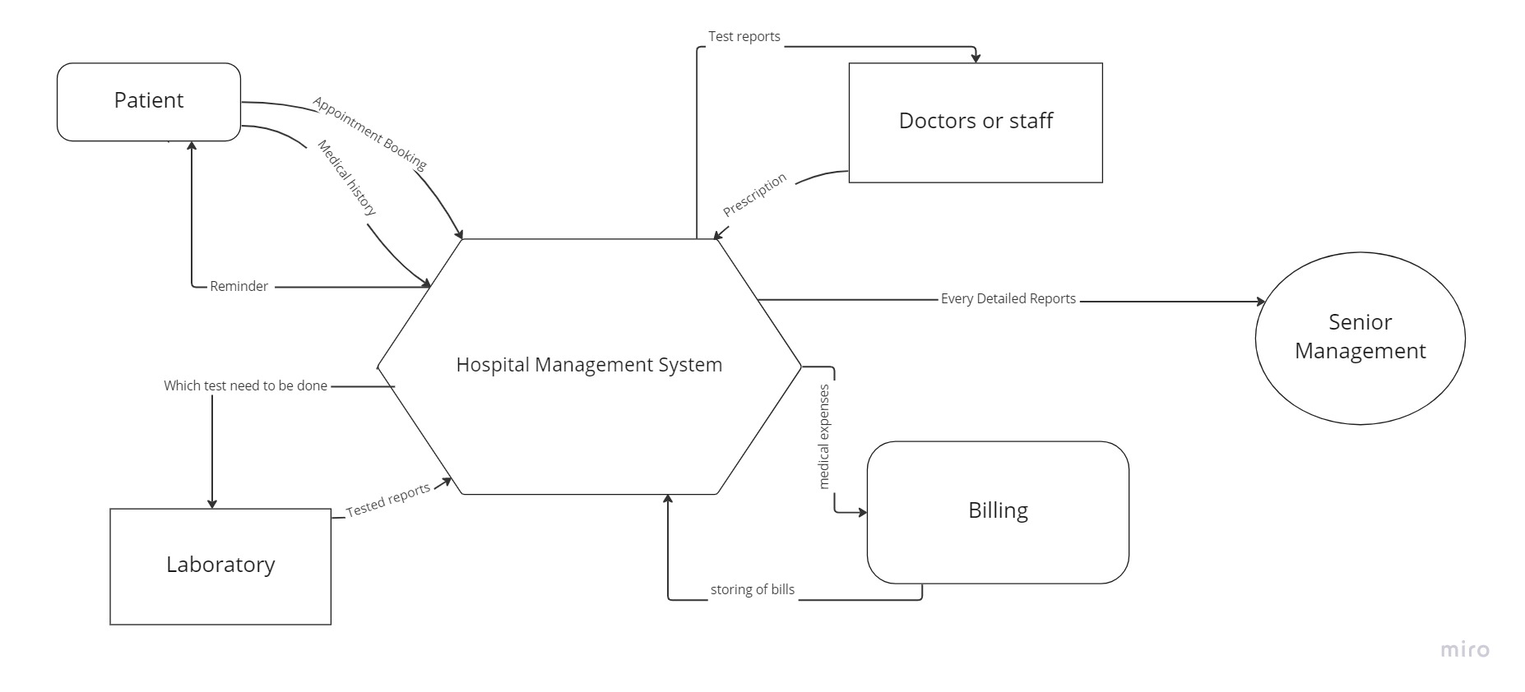

**Task-5**

**Main features: -**

1. Patient registration login
2. Reminders about appointment
3. Easy and user-friendly interface. Should be able to understand the login page by patient.
4. Storing medical reports for further references
5. Vacant and allocated beds of patient.
6. To get easy information to nurses which medication should be followed and particular time if patient was admitted.
7. Bill generation
8. Storage of insurance details if any, to claim
9. Reports for senior manager to know how many OPD’s were done, which doctor is getting more patient visits, earnings through OPD’s and lab tests and admission, and how many beds were getting occupied each and every day.

**TASK-6**

**Entity Relationship Diagram**

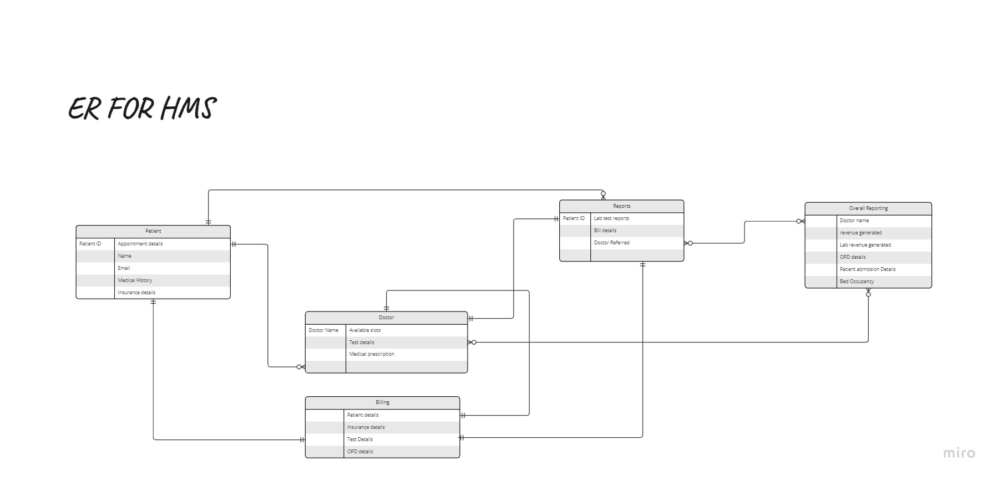

**Task-7**

**Data Flow Diagram Of HMS**

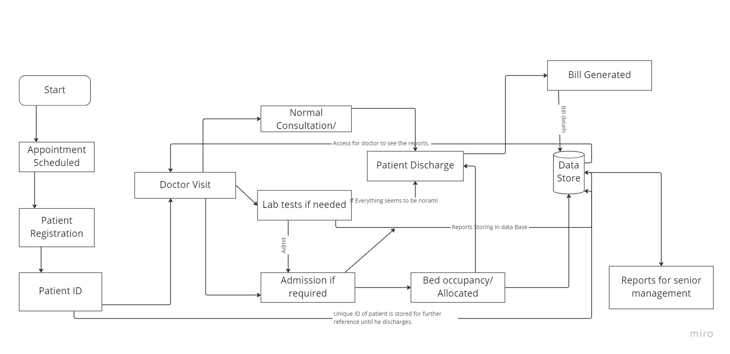

**TASK-8**

**Functional and Non-Functional requirements.**

**Functional Requirements**

Login page

Page to fill Patient details (which includes insurance details also)

To book and appointment for particular doctor

Medical records

Bed occupancy details page

Staff allocation details page

Billing page

Only access to all reports for senior management for further references.

**Non-functional Requirements**

Database used

OS used

**TASK-9**

**Flowchart for patient admission process**

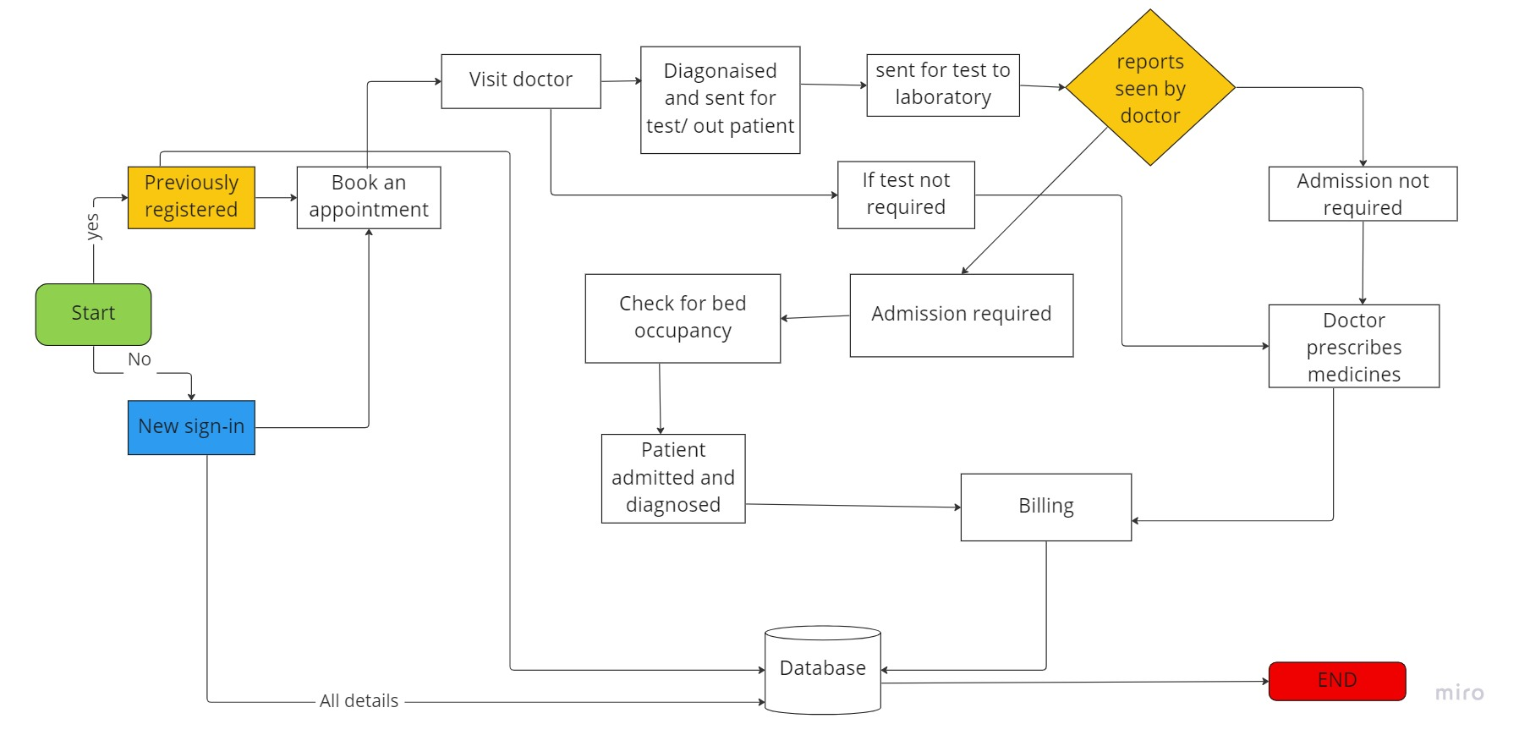

**TASK-10**

**MOCK SCREEN**

